[CREATE AND CONFIGURE IBM CLOUD SERVICES](https://careereducation.smartinternz.com/Student/guided_project_workspace/14105#collapse3)

|  |  |
| --- | --- |
| **TEAM ID** | **PNT2022TMID53703** |
| **PROJECT NAME** | **IOT BASED SMART CROP PROTECTION SYSTEM FOR AGRICULTURE** |

**STEP 1:**

First login your IBM cloud account using [http://cloud.ibm.com](http://cloud.ibm.com/) URL.

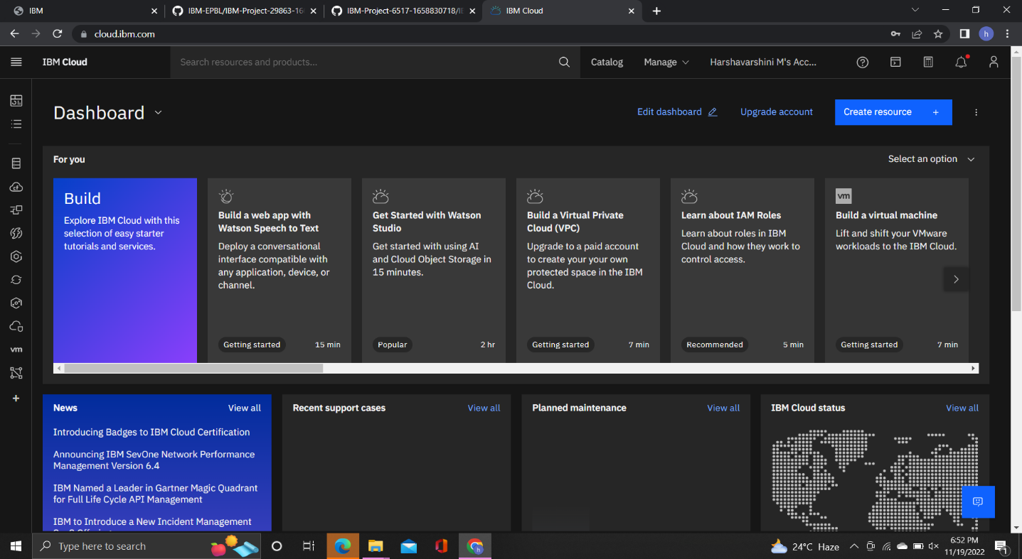

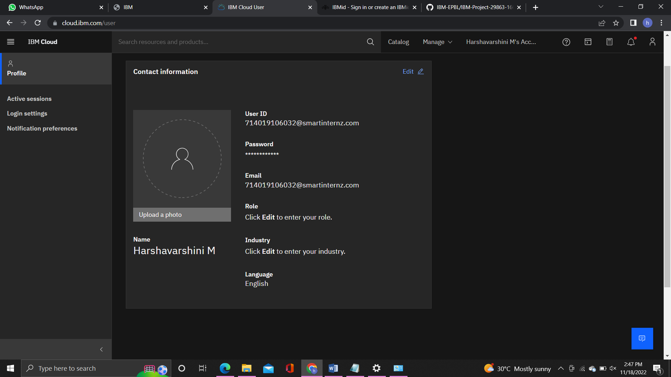

**STEP 2:**

Then open resource list tab and open Node Red YYCHD 2022-10-08 in Compute. And open [node-red-yychd-2022--cloudant-1667643063389-1946](https://cloud.ibm.com/services/cloudantnosqldb/4a3f98e7-9f85-423d-b52e-d90aff5c6232?env_id=ibm%3Ayp%3Aeu-de) [open this link.](https://cloud.ibm.com/services/cloudantnosqldb/4a3f98e7-9f85-423d-b52e-d90aff5c6232?env_id=ibm%3Ayp%3Aeu-de)

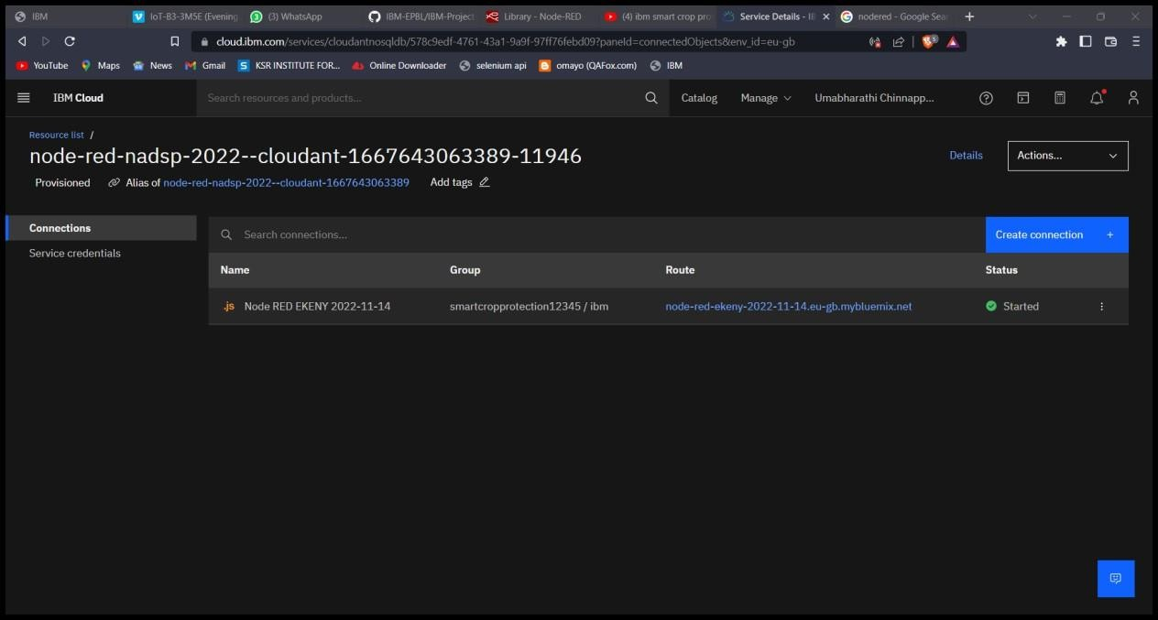

**STEP 3:**

Node-RED on IBM cloud.

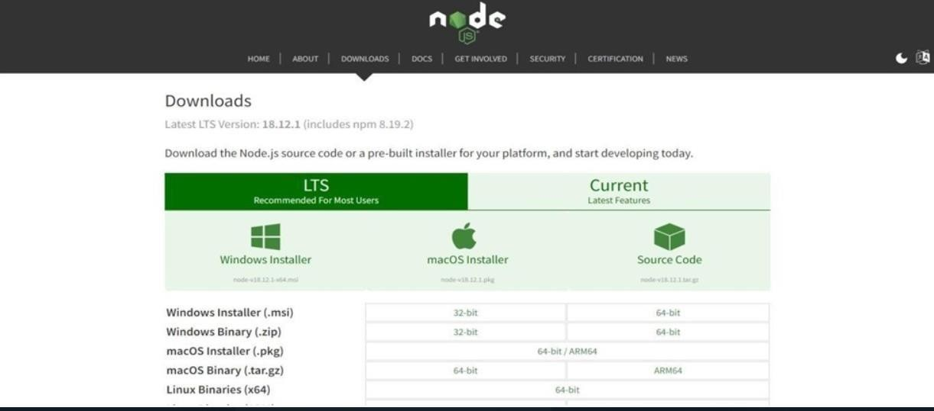

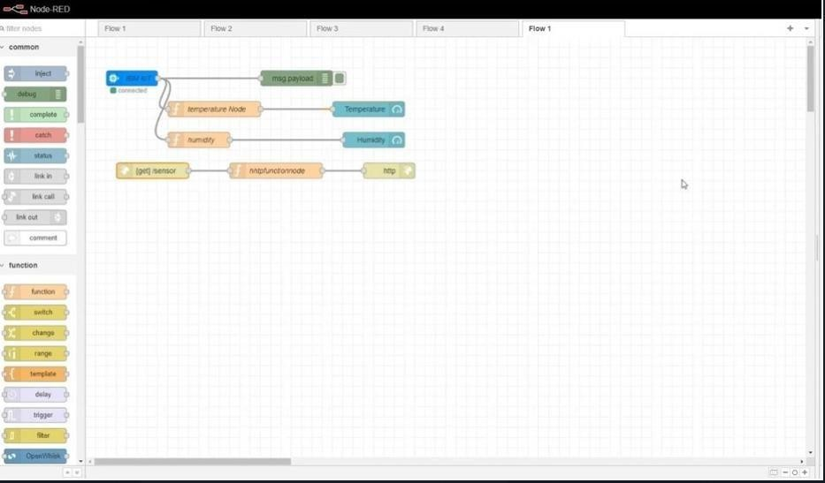

**STEP 4:**

This page shows the user interface of your Node-RED flow editor.

